Coin Pickup manual

Make sure tags you would want to create for the player is “Player” and for the Coin it requires “gameObject”. This allows the object to be destroyed when picked up.



Add the script to coin and the player model where you want on the scene and add the code to each model.

* Player model require script “UIController.cs”

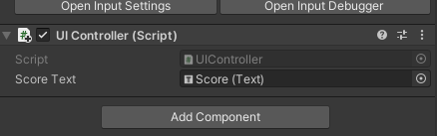

* Coin model require script “Pickup.cs” and “Spin.cs”

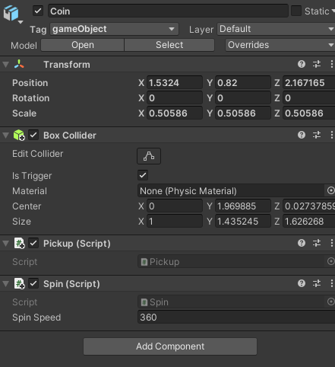

The coin would also require a box collider with “is trigger” ticked.

Create a text for your score which can be anything you want

* Right click and go to UI in the Hierarchy
* Then go to text (this will give Canvas with Text under it)
* Then go to the text box type in Score: 0 or anything you want (this would allow the coin to keep track of your score.
* Then put the score in a area where the player can see



make sure your unity project has input system for both (old and new) this will allow the scripts to work better with your project.